E X P E R I E N C E K I T S

Experience Kits are now available at the Butler Area Public Library. Kits include passes to 10 area museums and historical venues. Library cardholders may check out kits for one week on a first come, first served basis. If a patron wants to borrow a kit that is out on loan, library staff can place the cardholder on a waiting list.

Experience Kits are made possible through the History Center Affiliates Program of the Heinz History Center, Pittsburgh. To reserve a Kit, contact the library at 724-287-1715.

Most kits include general admission for up to four (4) along with visitor information for the following locals:

Gibson House Manor
210 Liberty St., Jamestown, PA 16134 (Mercer County)
Contact: 724 456-4983 or gibsonhousemanor@allfacilities.com
Hours: Visit the website for tour times. Tours have limited space and advance reservations are recommended. *Contact the venue to verify hours of operation as some times may be subject to change.

History Center Kit – This kit includes 3 great museums! *Contact the venue to verify hours of operation as some times may be subject to change.
Heinz History Center
1212 Smallman St. (Strip District), Pittsburgh, PA 15222
Contact 412-454-6000
Hours: Daily, 10AM-5PM. Closed on some holidays.

Fort Pitt Museum
Point State Park, Pittsburgh, PA 15222
Contact: 412-281-9284
Hours: Daily, 10AM-5PM. Closed on some holidays..

Meadowcroft Rockshelter and Historic Village
401 Meadowcroft Rd., Avella, PA 15312
Contact: 724-587-3412
Hours: Memorial Day to Labor Day, Wednesday – Sunday, 10AM-4PM; Labor Day to
October 29, Saturday & Sunday, 10AM-4PM

Historic Fort Steuben
120 S 3rd St., Steubenville, OH 43952
Contact: 740-283-1787
Hours: May to October, Monday – Friday, 10AM-4PM; Saturday, 10AM-4PM; Sunday, 11AM-4PM. *Contact the venue to verify hours of operation as some times may be subject to change.
Old Economy Village
Visitor's Center: 270 16th St., Ambridge, PA 15003
Contact: Heather Hicks at heathicks@pa.gov.
Hours: April 4 to December 20, 2026, Friday & Saturday, 10AM-4PM; Sunday, 12-4PM
*Contact the venue to verify hours of operation as some times may be subject to change.

Beaver Area Heritage Museum, Fort McIntosh & 1802 Log House
1 River Road, Beaver, PA 15009
Contact: 724-775-7174
Hours: Saturdays 10AM-4PM; First Sunday of each month, 1-4PM
Fort McIntosh Historic Site is located in a public park near the museum, open 24 hours.

BEAVER HERITAGE IMAGE:

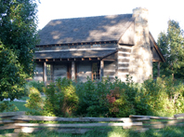

Bradford House & Whiskey Rebellion Education & Visitor Center
175 S. Main Street, Washington, PA 15301
Contact 724-222-3604
Hours: April to November, Wednesday – Saturday10AM-4PM (except holidays); Tours may be scheduled year-round by appointment.
*Contact the venue to verify hours of operation as some times may be subject to change.

BRADFORD HOUSE & WHISKEY REBELLION ED IMAGE:

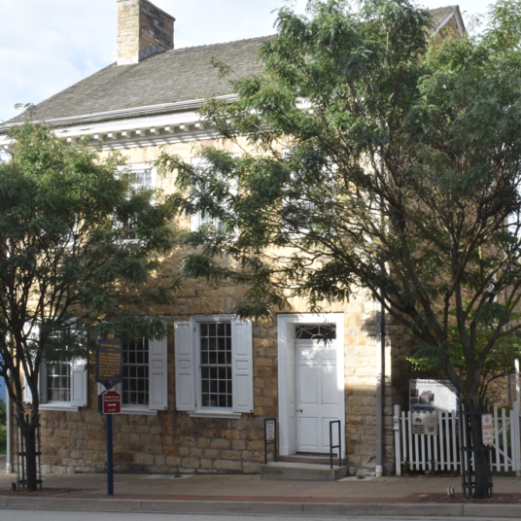

Lincoln Highway Experience
3435 State Route 30 E., Latrobe, PA 15650
Contact: 724-879-4241
Hours: April to November, Tuesday – Sunday, 10AM-4PM; December to March, Thursday – Sunday, 10AM-4PM
*Contact the venue to verify hours of operation as some times may be subject to change.

LINCOLN HIGHWAY EXPERIENCE IMAGE:

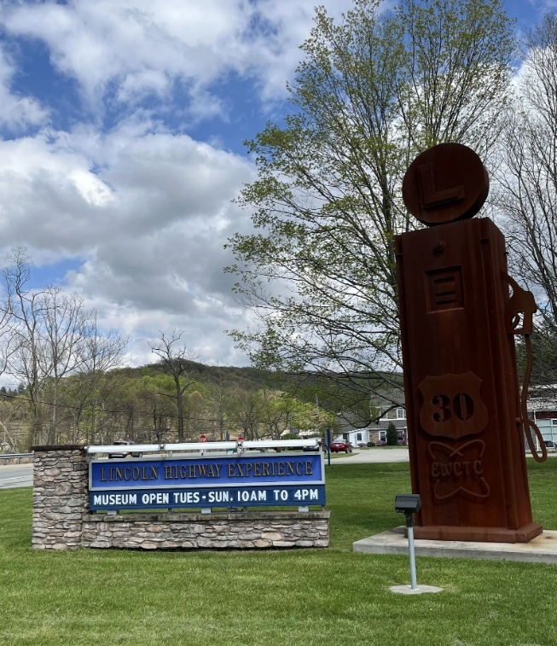

McKeesport Regional History & Heritage Center
1832 Arboretum Drive, McKeesport, PA 15132
Contact: 412-678-1832
Hours: Tuesday & Thursday, 10AM-4PM; Saturday, 10AM-3PM
*Contact the venue to verify hours of operation as some times may be subject to change.

MCKEESPORT REGIONAL IMAGE:

